“TICKET BOOKING SYSTEM”
A Project Report Submitted in the partial fulfillment of the requirements for the award of the degree of

BACHELOR OF TECHNOLOGY
In
DEPARTMENT OF COMPUTER SCIENCE AND INFORMATION TECHNOLOGY
By

SRR KEERTHI 2520090150
P JAHNAVI 2520090012

Under the Esteemed Guidance of Divya Priya Degala Assistant Professor

Department of Computer Science and Information Technology




K L (Deemed to be) University

DEPARTMENT OF COMPUTER SCIENCE AND INFORMATION TECHNOLOGY

Declaration

The Project Report entitled “Ticket Booking System” is a record of bonafide work of SRR. Keerthi – 2520090150 and P. Jahnavi – 2520090012, submitted in partial fulfillment of the requirements of the course Database Systems Engineering and Distributed Backend Development.
The project focuses on developing a reliable database-driven ticket reservation system that supports ticket availability, booking, cancellation, and booking history while addressing concurrent booking and double-booking problems.
The work presented in this report has been carried out as part of the academic project and has not been copied from any other student, department, or institution.

SRR. KEERTHI – 2520090150
P. JAHNAVI – 2520090012

K L (Deemed to be) University

DEPARTMENT OF COMPUTER SCIENCE AND INFORMATION TECHNOLOGY

CERTIFICATE

This is to certify that the project report entitled “Ticket Booking System” is a bonafide work done and submitted by SRR. Keerthi – 2520090150 and P. Jahnavi – 2520090012 in partial fulfillment of the requirements of the course Database Systems Engineering and Distributed Backend Development.
The project demonstrates the practical implementation of database management, transaction processing, concurrency control, and backend development for a reliable ticket reservation system.

Signature of the Guide

Signature of the Course Coordinator Signature of the HOD

ACKNOWLEDGEMENT
The success in this project would not have been possible but for the timely help and guidance rendered by many people. Our wish to express my sincere thanks to all those who has assisted us in one way or the other for the completion of my project.

Our greatest appreciation to my Course Coordinator Dr , and my guide Divya Priya Degala, Department of Computer Science and Information Technology which cannot be expressed in words for his/her tremendous support, encouragement and guidance for this project.

We express our gratitude to Dr. Kaja Shareef, Head of the Department for Computer Science and Information Technology for providing us with adequate facilities, ways and means by which we are able to complete this project-based Lab.

We thank all the members of teaching and non-teaching staff members, and also who have assisted me directly or indirectly for successful completion of this project. Finally, I sincerely thank my parents, friends and classmates for their kind help and cooperation during my work.

SRR KEERTHI – 2520090150

P JAHNAVI – 2520090012

Abstract

The Ticket Booking System is a database-driven application designed to provide a reliable and secure ticket reservation process. The system allows users to view available tickets, make bookings, cancel reservations, and check their booking history.
The major challenge addressed by the project is concurrent booking, where multiple users may attempt to reserve the same ticket at the same time. If concurrent requests are not handled properly, the same ticket may be booked by more than one user, resulting in double booking and inconsistent database records.
To solve this problem, the system uses database transactions and concurrency-control mechanisms. The backend verifies ticket availability and safely processes each booking request before updating the database. Database locking mechanisms help prevent conflicting transactions and ensure that only one user can successfully reserve a particular ticket.
The project demonstrates the practical application of database management, transaction processing, concurrency control, locking mechanisms, and backend development to build a reliable ticket-booking system.

Index
S.No. | Chapters | Topics | Page No.
 |  | Acknowledgement
 |  | Abstract
1 | Introduction | - Background of the Project  - Problem Statement  - Scope of the Project  - Objectives  - Importance of the Application  - Target Users / Audience | 5
2 | System Requirements | - Hardware Requirements  - Software Requirements  - Development Tools and Frameworks | 7
3 | Technology Stack | - Frontend  - Backend  - Database  - Version Control  - Authentication and Security Libraries | 8
4 | System Architecture | - High-Level Architecture Diagram  - Description of Each Layer  - Deployment Architecture | 9
5 | Design | - Database Design Principles  - ER Diagram / Database Schema  - Design Decisions and Assumptions | 10
6 | Implementation | - Module-wise Implementation  - Front-end Logic  - API Integration  - Authentication and Authorization | 12
7 | Features | - List of Main Features  - How Each Feature Works | 13
8 | Testing | - Postman API Testing  - Integration Testing  - Tools Used for Testing  - Test Cases and Results | 15
9 | Deployment | - Steps to Deploy  - Environment Configuration  - Hosting of Frontend and Backend | 17
10 | Challenges & Limitations | - Issues Faced During Development  - Solutions Applied  - Current Limitations or Known Bugs | 18

S.No. | Chapters | Topics | Page No.
11 | Future Enhancements | - Planned Features  - Possible Integrations or Optimizations | 19
12 | Conclusion | - Summary of the Project  - What Was Achieved  - Skills Learned | 20
13 | References | – Documentation, tools, and resources used | 21
14 | Appendices | - Sample Code Snippets  - Installation / Setup Instructions  - Default Login Credentials  - API Reference Summary  - Screenshots (to be added by the student) | 22

CHAPTER 1: INTRODUCTION
  - Background of the Project

Ticket booking systems are widely used for booking tickets for movies, transportation, events, and other services. A ticket booking system allows users to check available tickets, select a ticket, make a reservation, cancel a booking, and view their booking history.
In a system where many users access the application at the same time, multiple users may try to book the same ticket simultaneously. This creates a major database problem known as double booking.
The Ticket Booking System is designed to provide a centralized and reliable platform for managing ticket reservations. The system uses a MySQL database to store ticket and booking information and a backend application to process user requests. Database transactions and concurrency-control mechanisms are used to maintain data consistency when multiple users attempt to book tickets simultaneously.

1.2 Problem Statement
In a ticket booking system, many users may attempt to reserve the same ticket at the same time. If these requests are processed without proper concurrency control, the same ticket may be assigned to multiple users.
This results in double booking, incorrect ticket availability, inconsistent database records, and poor user experience.
Therefore, the system must reliably verify ticket availability, process booking requests safely, and ensure that only one user can reserve a particular ticket when concurrent requests occur.

1.3 Scope of the Project
The Ticket Booking System covers the basic lifecycle of ticket reservations.
The system allows users to:
- View available tickets.
- Select and reserve tickets.
- Confirm bookings.
- Cancel reservations.
- View booking history.
- Check ticket availability.
The backend manages booking requests and communicates with the MySQL database. The system also focuses on handling multiple booking requests simultaneously using database transactions and concurrency-control mechanisms.
The project mainly focuses on database management, transaction processing, concurrency control, and reliable ticket reservation.

1.4 Objectives
The main objectives of the Ticket Booking System are:
- To provide a simple and reliable ticket booking platform.
- To allow users to view available tickets.
- To allow users to book and cancel tickets.
- To maintain booking history.
- To prevent double booking of the same ticket.
- To handle multiple users accessing the system simultaneously.
- To maintain database consistency during concurrent transactions.
- To use database transactions for safe booking operations.
- To demonstrate the use of concurrency-control and locking mechanisms.

1.5 Importance of the Application
The Ticket Booking System is important because it provides a reliable way of managing ticket reservations.
The system reduces errors that can occur when multiple users try to book the same ticket. By using transactions and concurrency-control mechanisms, the system helps prevent double booking and maintains consistent database information.
It also provides users with easy access to ticket availability, booking, cancellation, and booking history.

1.6 Target Users / Audience
The main users of the Ticket Booking System are:
- Customers/Users: View available tickets, make bookings, cancel reservations, and check booking history.
- System Administrator: Manage ticket information, monitor bookings, and maintain the database.

CHAPTER 2: SYSTEM REQUIREMENTS

Hardware Requirements
The application has modest hardware requirements, since both the Node.js backend and the MySQL database are lightweight relative to the small dataset a single campus generates. A development or demonstration machine with a dual-core processor, 4 GB of RAM, and roughly 500 MB of free disk space (for Node modules, MySQL data files, and project source) is sufficient to run the entire stack — frontend, backend, and database — on one computer.

Software Requirements
  - Java Development Kit (JDK)
  - MySQL Database
  - React.js
  - Visual Studio Code
  - Web Browser
  - MySQL client/tool for database management

Development Tools and Frameworks
The project uses Java for backend programming, MySQL for database management, and React.js for the frontend. Visual Studio Code is used as the development environment.
The backend communicates with the MySQL database to process ticket availability and booking operations. The React.js frontend provides the user interface for interacting with the ticket booking system.

CHAPTER 3: TECHNOLOGY STACK

Frontend
The frontend of the Ticket Booking System is developed using React.js, providing a simple and user-friendly interface for ticket reservation. It allows users to view available tickets, select tickets, make bookings, cancel reservations, make your travelling plan according the budget and check their booking history. The frontend communicates with the Java backend to send booking requests and receive ticket availability and booking information. The interface is designed using standard web technologies and focuses on providing a clear and easy-to-use experience for users.

Backend
The backend of the Ticket Booking System is developed using Java and is responsible for handling ticket availability, booking requests, cancellations, and booking history. It communicates with the MySQL database to store and retrieve ticket and booking information. The backend also checks ticket availability and uses database transactions and concurrency-control mechanisms to prevent multiple users from booking the same ticket at the same time. This ensures that bookings are processed safely and accurately.

Database
MySQL is used as the database management system for the Ticket Booking System. It stores ticket and booking information and helps the backend retrieve and update data during the booking process. Database transactions and concurrency-control mechanisms are used to safely process booking requests when multiple users try to reserve the same ticket. This helps maintain accurate ticket availability and prevents double booking.

Version Control
Git and GitHub can be used for maintaining and managing the project source code during development. The project files, including the React.js frontend and Java backend, can be maintained in a common repository. Version control helps track changes to the project and makes it easier to manage different versions of the code.

Authentication and Security Libraries
The Ticket Booking System focuses on securely processing booking requests and protecting ticket availability from conflicting transactions. The backend verifies whether a ticket is available before completing a booking. Database transactions and concurrency-control mechanisms help ensure that when multiple users attempt to book the same ticket at the same time, only one booking is successfully completed. This prevents double booking and maintains the consistency of the booking data.

CHAPTER 4: SYSTEM ARCHITECTURE

High-Level Architecture Diagram
The Ticket Booking System follows a three-layer architecture consisting of the Presentation Layer, Application Layer, and Data Layer. The Presentation Layer provides the user interface using React.js. The Application Layer is developed using Java and handles ticket availability, booking, cancellation, and booking-related operations. The Data Layer uses MySQL to store ticket and booking information. The three layers work together to process user requests and safely manage ticket reservations.

Description of Each Layer
The Presentation Layer is the React.js frontend of the Ticket Booking System. It provides an easy-to-use interface through which users can view available tickets, make bookings, cancel reservations, and check their booking history. The frontend sends user requests to the Java backend and displays the information received from the backend.
The Application Layer is the Java backend of the system. It receives requests from the React.js frontend and handles the main booking operations. It checks ticket availability, processes booking and cancellation requests, and retrieves booking history. During concurrent booking requests, the backend uses database transactions and concurrency-control mechanisms to ensure that the same ticket is not booked by multiple users.
The Data Layer is the MySQL database. It stores ticket and booking information and provides the required data to the Java backend. The database is updated when tickets are booked or cancelled. Transactions and concurrency control help maintain data consistency and prevent double booking.

Deployment Architecture
For development and demonstration, the Ticket Booking System can be run on a local computer using the React.js frontend, Java backend, and MySQL database. The React.js application provides the user interface, while the Java backend processes booking-related requests and communicates with the MySQL database. The database stores ticket availability and booking information. This setup allows the complete system to be developed, tested, and demonstrated on a single machine using Visual Studio Code as the development environment.

CHAPTER 5: DESIGN

Database Design Principles
The database of the Ticket Booking System is designed to store ticket and booking information in an organized manner. The database helps maintain accurate information about available tickets, completed bookings, cancelled reservations, and booking history. Appropriate database constraints are used to maintain data consistency and avoid invalid or duplicate booking information. Database transactions and concurrency-control mechanisms are also considered important to ensure that multiple users cannot successfully reserve the same ticket at the same time.

ER Diagram / Database Schema
The database consists of seven related tables, shown in Figure 5.1.
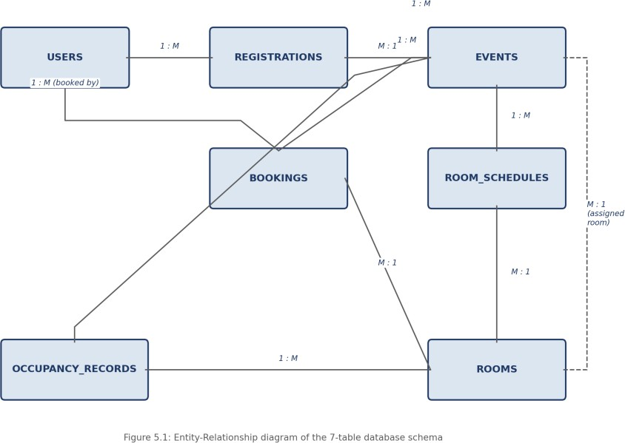
The database schema of the Ticket Booking System contains the data required to manage tickets and reservations. The main information includes ticket availability, user booking details, cancellation information, and booking history. The Java backend communicates with the MySQL database to create, retrieve, update, and manage booking records.
The database plays an important role during the booking process. When a user attempts to book a ticket, the system checks its availability before completing the reservation. Once the booking is successfully processed, the corresponding ticket and booking information is updated in the database. If a ticket is already reserved, the system prevents another user from booking the same ticket. This helps maintain accurate booking records and prevents double booking.

Design Decisions and Assumptions
The main design decision of the Ticket Booking System is to give importance to accurate ticket availability and safe booking operations. The system assumes that multiple users may try to book the same ticket at the same time. Therefore, database transactions and concurrency-control mechanisms are used while processing booking requests.
Another important decision is to maintain booking and cancellation information so that users can check their booking history. The Java backend is responsible for processing these operations, while MySQL stores the corresponding data. These decisions help maintain consistency and reduce the possibility of duplicate or conflicting bookings.

CHAPTER 6: IMPLEMENTATION

Module-wise Implementation
The Ticket Booking System consists of the following major modules:
  - User Management
  - Ticket Availability
  - Ticket Booking
  - Ticket Cancellation
  - Booking History
  - Database Management
  - Concurrency Control

Front-end Logic
The React.js frontend provides the interface for users to interact with the Ticket Booking System. Users can view available tickets, select a ticket, make a booking, cancel a reservation, and check their booking history.
When a user requests a ticket booking, the request is sent to the Java backend. The backend checks whether the requested ticket is available before completing the booking. If the ticket has already been booked, the system does not allow another user to reserve the same ticket.

API Integration
The React.js frontend communicates with the Java backend to perform ticket-related operations. Requests are sent from the frontend to the backend for checking ticket availability, making bookings, cancelling reservations, and retrieving booking history. The Java backend processes these requests and communicates with the MySQL database to store or retrieve the required information. This separation allows the frontend to focus on user interaction while the backend handles the main booking logic.

Authentication and Authorization
The Ticket Booking System manages users who access the ticket booking features. User requests are processed by the Java backend before the corresponding booking operation is performed. The backend verifies the required information and communicates with the MySQL database to process the request.
The system also focuses on preventing unauthorized or conflicting booking operations. During a booking request, the backend checks ticket availability and uses database transactions and concurrency-control mechanisms. This ensures that when multiple users try to book the same ticket at the same time, only one user can successfully reserve it, preventing double booking.

CHAPTER 7: FEATURES

List of Main Features
The Ticket Booking System provides the following main features:
  - View available tickets
  - Check ticket availability before booking
  - Book an available ticket
  - Prevent multiple users from booking the same ticket
  - Cancel a ticket reservation
  - View booking history
  - Store and manage ticket and booking information using MySQL
  - Process booking requests through the Java backend
  - Provide a user-friendly interface using React.js
  - Use database transactions and concurrency-control mechanisms for safe ticket booking

How Each Feature Works

Ticket Availability Checking: When a user wants to book a ticket, the system first checks whether the requested ticket is available. The availability information is retrieved from the MySQL database through the Java backend. If the ticket is available, the user can continue with the booking process.

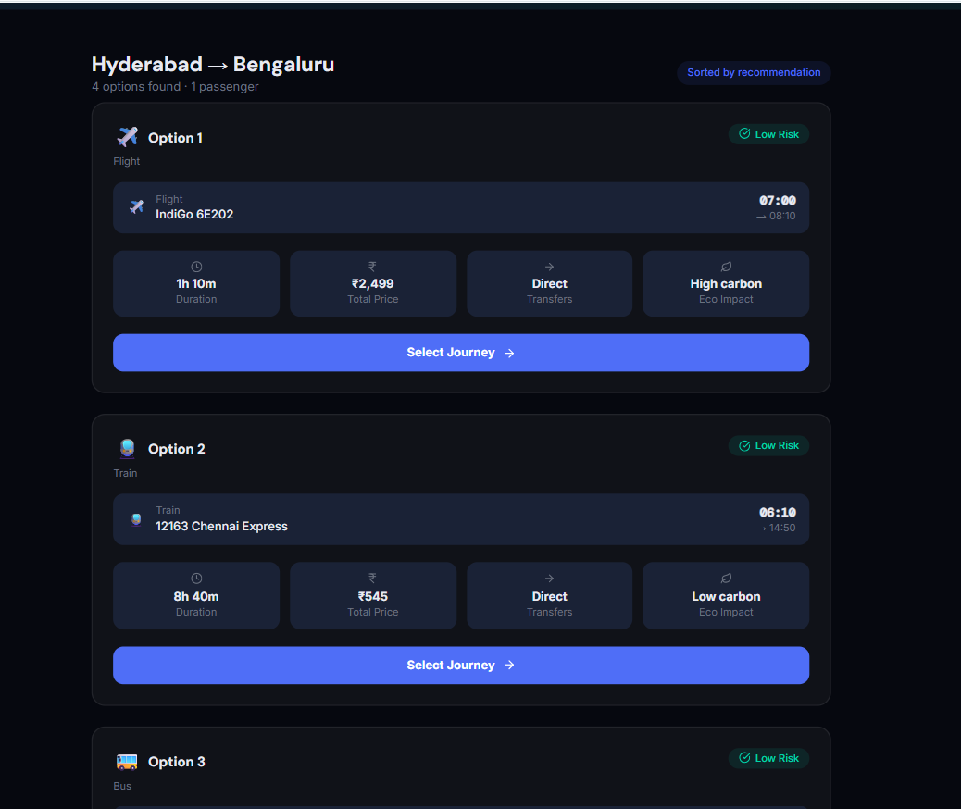

Ticket Booking: After checking availability, the user can request to reserve the ticket. The Java backend processes the booking request and updates the booking information in the MySQL database. Database transactions are used to safely complete the booking operation.
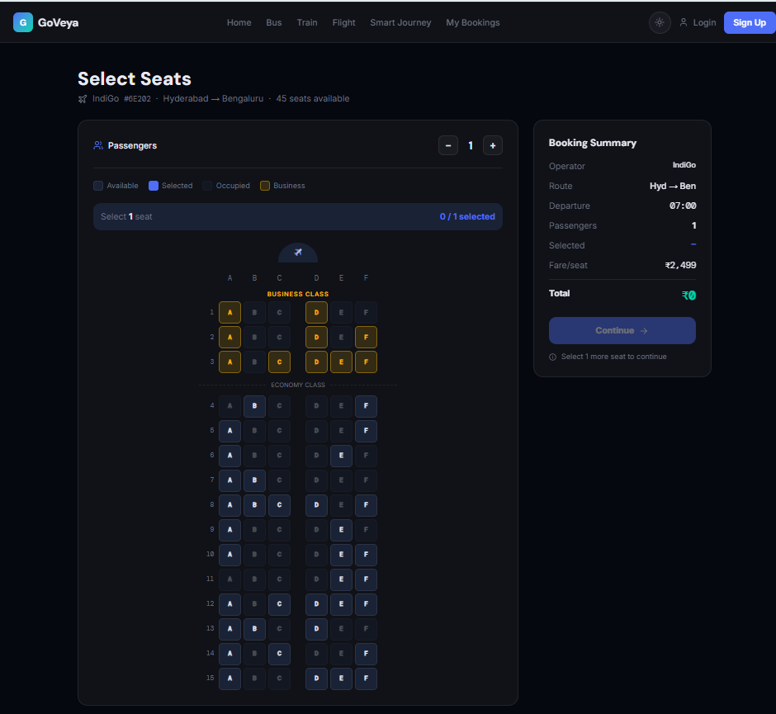

Concurrency Control: Multiple users may try to book the same ticket at the same time. The system uses concurrency-control mechanisms to manage these requests. Only one user can successfully reserve a particular ticket, while other users are informed that the ticket is no longer available. This prevents double booking.
Ticket Cancellation: Users can cancel an existing reservation. When a booking is cancelled, the corresponding booking information is updated in the database and the ticket can become available again according to the system's booking rules.
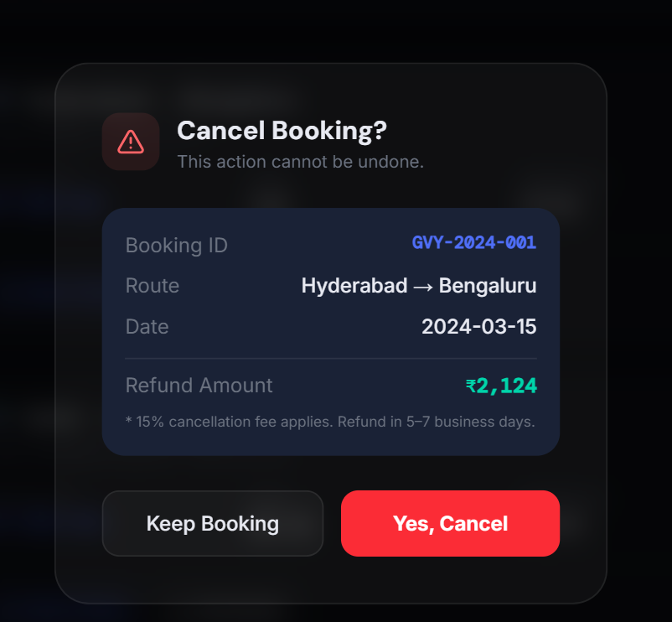

Booking History: The system stores booking information so that users can check their previous reservations. This provides users with a record of their ticket bookings and cancellations.
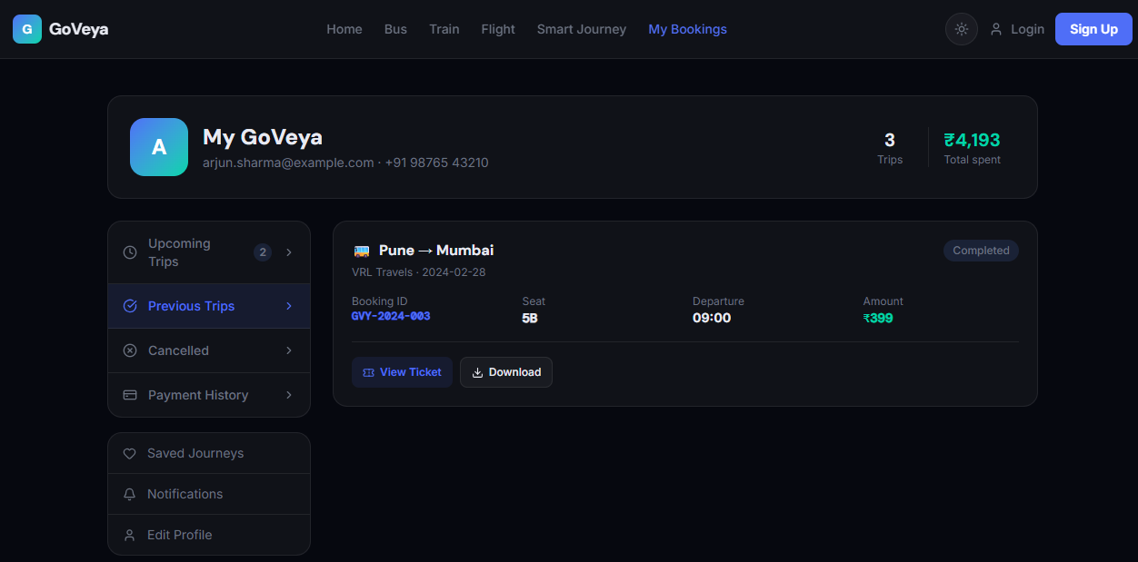
Database Management: MySQL is used to store and manage ticket and booking information. The Java backend communicates with the database whenever ticket or booking information needs to be retrieved or updated.

CHAPTER 8: TESTING

Postman API Testing
The Ticket Booking System was tested to verify that the frontend, Java backend, and MySQL database communicate correctly. The booking-related operations were tested by sending requests from the frontend to the backend and checking the responses.
The main operations tested include checking ticket availability, booking a ticket, cancelling a reservation, and viewing booking history. Special attention was given to concurrent booking requests to verify that multiple users cannot successfully reserve the same ticket.

Integration Testing
Integration testing was performed to verify the complete flow between the React.js frontend, Java backend, and MySQL database. The system was tested by performing actual ticket-related operations and checking whether the corresponding information was correctly stored and retrieved from the database.
The booking process was also tested from beginning to end. The system checks ticket availability, processes the booking request, updates the database, and displays the booking result to the user. Cancellation and booking-history operations were also checked to ensure that the database information remains consistent.

Tools Used for Testing
The following methods and tools were used for testing the Ticket Booking System:
  - React.js frontend — manual testing of the user interface and booking operations
  - Java backend — testing the booking and database-processing logic
  - MySQL — verification of ticket and booking information stored in the database
  - Visual Studio Code — development and execution of the project
  - Manual testing — checking different booking, cancellation, and availability scenarios

Test Cases and Results
A representative sample of the test cases executed, drawn from the project's actual test log, is summarized below.

# | Test Case | Expected Result | Actual Result
1 |  | Available tickets are displayed | Pass
  View available tickets
2 | Book an available ticket |  | Pass
  Ticket is successfully booked
3 |  |  | Pass
  Try to book an already booked ticket
  Booking is rejected
4 | Two users try to book the same ticket at the same time |  | Pass
  Only one booking is successful
5 | Cancel an existing booking |  | Pass
  Booking is cancelled successfully
6 |  |  | Pass
  View booking history
  Previous bookings are displayed
7 |  | Booked ticket is shown as unavailable | Pass
  Check ticket availability after booking
8 |  | Cancelled ticket becomes available according to the system rules | Pass
  Check ticket availability after
  Cancellation
9 | Store booking information | Booking details are correctly stored in MySQL | Pass
10 | Retrieve booking information | Correct booking information is displayed | Pass
11 |  | Database concurrency control prevents double booking | Pass
  Multiple concurrent booking requests
12 |  | System rejects the invalid request and does not create an incorrect booking
  Invalid booking request
The most important test is the concurrent booking test. Multiple users may attempt to reserve the same ticket at the same time. The system uses database transactions and concurrency-control mechanisms so that only one user can successfully reserve the ticket. This confirms that the system addresses the main double-booking problem identified in the project.
further in Chapter 10.

CHAPTER 9: DEPLOYMENT

Steps to Deploy
The Ticket Booking System can be run locally for development and demonstration using the following steps:
  - Start the MySQL database and make sure the required database is available.
  - Create or load the required ticket and booking tables in MySQL.
  - Start the Java backend application.
  - Start the React.js frontend application.
  - Open the frontend application in a web browser.
  - View the available tickets and test the booking, cancellation, and booking-history features.
  - Test multiple booking requests to verify that the concurrency-control mechanism prevents double booking.

Environment Configuration
The Ticket Booking System requires the Java backend, MySQL database, and React.js frontend to be configured correctly before execution. The database configuration is used by the Java backend to connect to MySQL and access ticket and booking information. The frontend is configured to communicate with the Java backend for booking-related operations.
The required project configuration should be kept separate from the main application code where appropriate. Database connection details should be configured according to the local development environment.

Hosting of Frontend and Backend
For development and demonstration, the Ticket Booking System can be run locally on a single computer. The React.js frontend provides the user interface, while the Java backend handles the booking operations and communicates with the MySQL database.
The MySQL database stores ticket availability and booking information. This local setup is suitable for testing and demonstrating the complete ticket booking workflow, including ticket availability checking, booking, cancellation, booking history, and prevention of double booking. A cloud-based production deployment can be considered as a future enhancement.

CHAPTER 10: CHALLENGES & LIMITATIONS

Issues Faced During Development
The main challenges faced during the development of the Ticket Booking System were:
  - Preventing double booking when multiple users try to reserve the same ticket at the same time.
  - Maintaining correct ticket availability after a booking is completed.
  - Ensuring that booking and cancellation operations correctly update the information stored in the MySQL database.
  - Managing concurrent booking requests so that conflicting requests do not result in incorrect or duplicate booking records.
  - Maintaining proper communication between the React.js frontend, Java backend, and MySQL database.

Solutions Applied
To handle concurrent booking requests, database transactions and concurrency-control mechanisms were used. Before confirming a booking, the system checks the availability of the requested ticket. The booking operation is processed safely so that only one user can successfully reserve the same ticket when multiple users attempt to book it simultaneously.
The Java backend handles the booking and cancellation logic, while MySQL stores and updates the ticket and booking information. This separation helps maintain consistency between the user interface, backend processing, and database.
Testing was also performed for different booking situations, including available tickets, already-booked tickets, cancellations, and simultaneous booking requests. These tests help verify that the system behaves correctly and prevents double booking.

Current Limitations or Known Bugs
The current limitations of the Ticket Booking System include:
  - The system is designed mainly for development and demonstration and has not been deployed to a public cloud environment.
  - The system depends on the availability of the Java backend and MySQL database for processing booking operations.
  - The project focuses on the core ticket booking process and may require additional features for a complete real-world ticket reservation platform.
  - Advanced features such as online payment integration, email or SMS booking notifications, and automated ticket delivery are not currently included.
  - The system requires further testing with a larger number of simultaneous users to evaluate its performance under heavy load.

CHAPTER 11: FUTURE ENHANCEMENTS

Planned Features
The following features can be added to the Ticket Booking System in the future:
  - Online payment integration so users can securely pay for their tickets through the system.
  - Email or SMS notifications for booking confirmation, cancellation, and other ticket-related updates.
  - Digital ticket generation with a unique booking ID or QR code for easier verification.
  - Improved search and filtering options to help users find tickets more easily.
  - User profile management where users can view and manage their personal booking information.
  - A more detailed booking management system for viewing and managing current and previous reservations.
  - Improved handling of large numbers of simultaneous users to support higher booking traffic.

Possible Integrations or Optimizations
The Ticket Booking System can be further improved through additional integrations and optimizations:
  - Integrating a secure online payment service for completing ticket purchases.
  - Adding email or SMS services for automatic booking and cancellation notifications.
  - Optimizing the MySQL database queries to improve response time when many users access the system simultaneously.
  - Improving the concurrency-control mechanism to efficiently handle a large number of simultaneous booking requests.
  - Deploying the React.js frontend, Java backend, and MySQL database on a cloud platform so that the system can be accessed remotely.
  - Adding automated testing to reduce errors and verify that future changes do not affect existing booking functionality.
  - Adding monitoring and logging features to help identify booking failures and system performance issues.

CHAPTER 12: CONCLUSION

Summary of the Project
The Ticket Booking System was developed as a database-driven application to provide a simple and reliable way of managing ticket reservations. The system allows users to view available tickets, make bookings, cancel reservations, and check their booking history. The project uses React.js for the frontend, Java for the backend, and MySQL for database management. A major focus of the project is handling concurrent booking requests and preventing multiple users from successfully reserving the same ticket.

What Was Achieved
The completed system provides the main functions required for ticket reservation. Users can check ticket availability, book available tickets, cancel reservations, and view their booking history. The Java backend communicates with the MySQL database to process and store booking information.
An important achievement of the project is the implementation of database transactions and concurrency-control mechanisms. These mechanisms help ensure that when multiple users try to book the same ticket at the same time, only one user can successfully reserve it. This prevents double booking and helps maintain the consistency and reliability of the booking data.

Skills Learned
Working on this project provided practical experience in developing a database-driven web application. The project helped in understanding React.js frontend development, Java backend programming, and MySQL database management. It also provided experience in handling ticket availability, booking and cancellation operations, and maintaining booking records.
The project also helped in understanding database transactions and concurrency control. Testing different booking situations helped demonstrate how concurrent requests can be handled safely and how double booking can be prevented. Overall, the project provided practical knowledge of frontend development, backend processing, database management, and safe transaction processing.

CHAPTER 14: APPENDICES

Appendix A: Sample Code Snippet

The following type of logic is used during the ticket booking process:

Check whether the requested ticket is available.

Start the booking transaction.

Reserve the ticket if it is available.

Update the booking information in the database.

Complete the transaction.

If the ticket is already booked, reject the booking request.

This transaction-based approach helps prevent two users from successfully booking the same ticket at the same time.

Appendix B: Installation and Setup Instructions
The Ticket Booking System can be set up locally using the following steps:
• Install and configure Java.
• Install and configure MySQL.
• Create the required Ticket Booking database in MySQL.
• Create the required tables for storing ticket and booking information.
• Configure the Java backend to connect to the MySQL database.
• Start the Java backend application.
• Start the React.js frontend application.
• Open the frontend application in a web browser.
• Test ticket availability, booking, cancellation, and booking history.
• Test concurrent booking requests to verify that double booking is prevented.

Appendix C: Default Login Credentials

Role | Email
Admin | Keerthivarma1608@gmail.com
User | moonlitkeeps@gmail.com
User | starlitnotes@gmail.com
Users | rahul.varma@ gmail.com,,ananya.rao@gmail.com, kiran.kumar@ gmail.com, , sneha.patil@ gmail.com,

Appendix D: API Reference Summary

The Ticket Booking System uses backend operations to communicate between the React.js frontend, Java backend, and MySQL database.

The main operations include:

Resource | Endpoints
Ticket Availability
  View and check available tickets
Ticket Booking
  Create and confirm a ticket booking
Ticket Cancellation | Cancel an existing reservation
Booking History | View previous booking information
Database Management
  Store and retrieve ticket and booking information
Concurrency Control
  Safely process simultaneous booking requests

Appendix E: Screenshots
The following pages are left for the USER to complete with actual screenshots taken from the running application before submission. Suggested screenshots, in order:
- Home
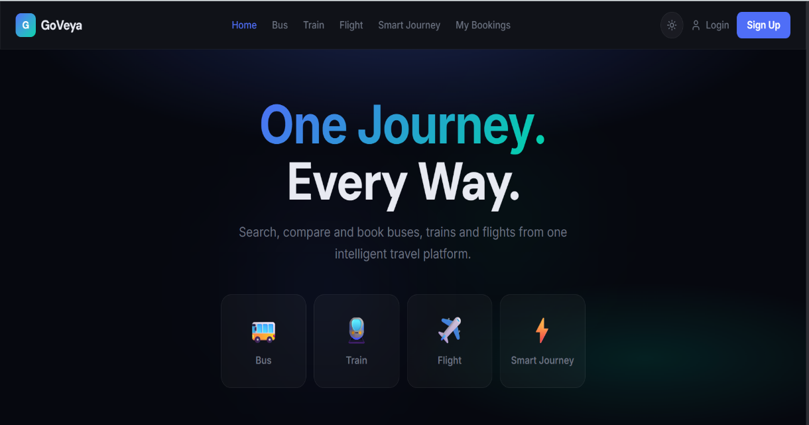
- Login/ Signup
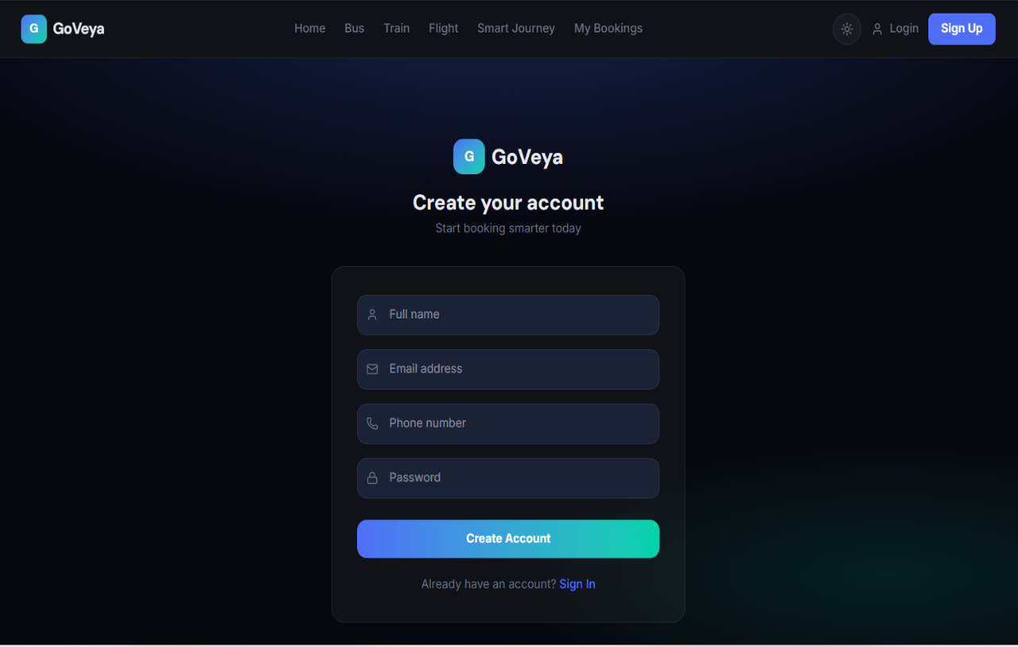

- Smart Journey plan
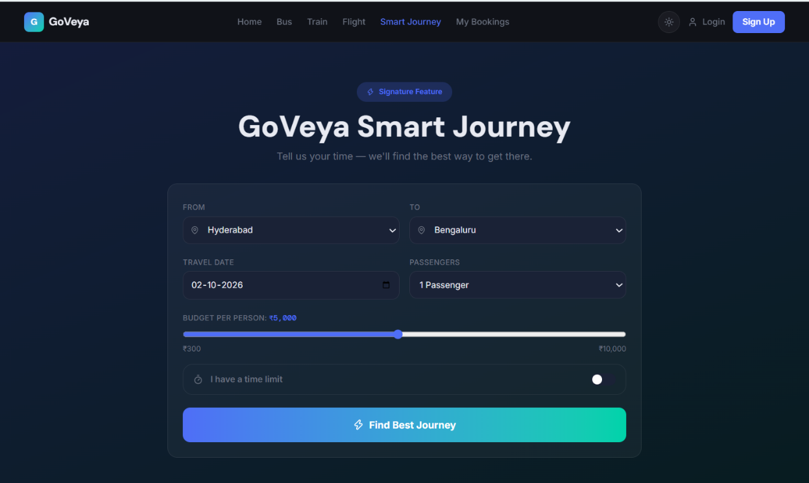
- Sear select

- Passenger detail
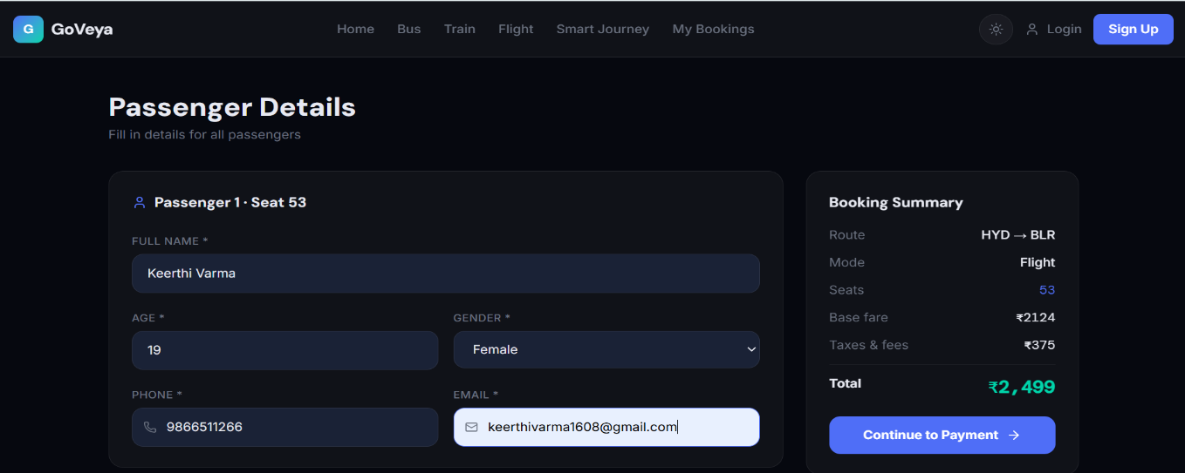
- Cancellation
- Previous trips
- Payment
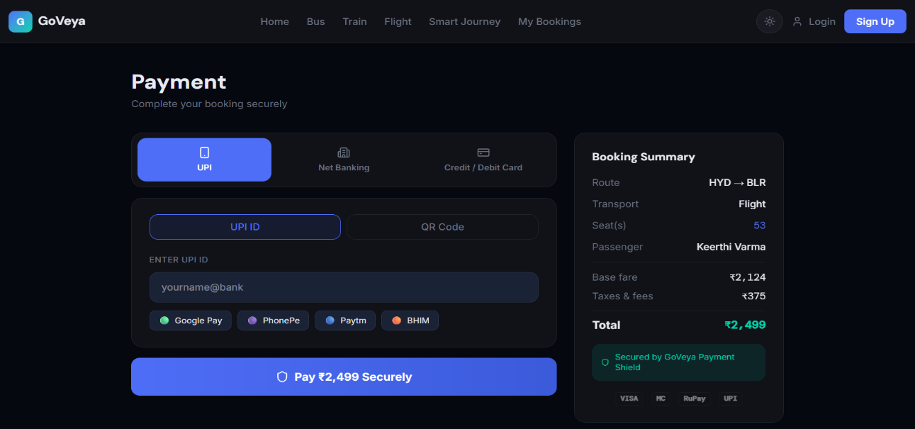
- Download Ticket
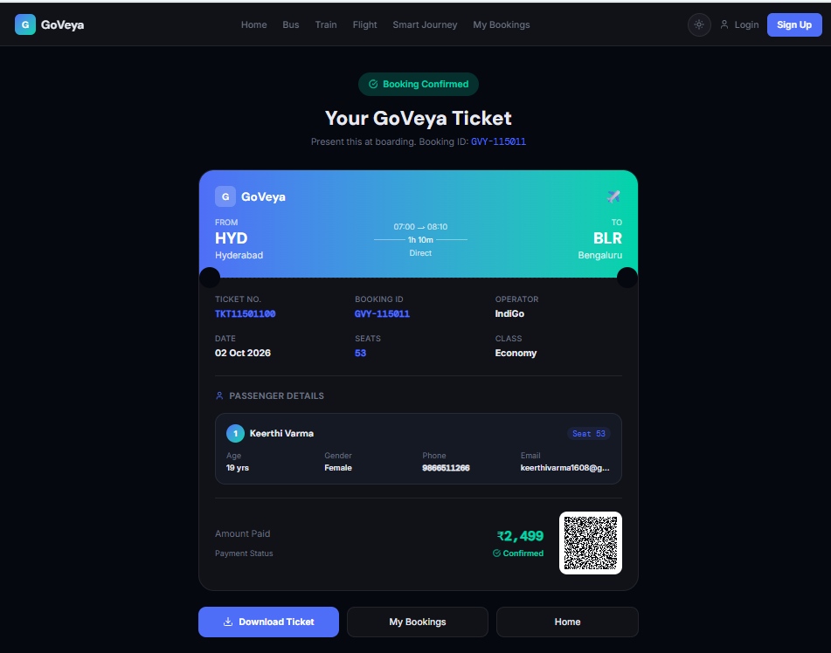
- Admin page
